|  |
| --- |
| Imagine Dragoons |
| Assessment 3 |
| Team Project |

|  |
| --- |
| Ryan Williams, Benjamin King, Morgan Cassar, Douglas Baker, Ty Lynch-Palmer, Robert Cross |

Team Profile 4

Robert Cross 4

Meyer-Briggs Test 4

Personality test 5

Numeracy Test 5

Ryan Williams 6

Meyer-Briggs Test 6

Learning style Test 6

Psychometric Test 7

Benjamin King 7

Myer-Briggs Test 7

Learning Style test 8

Douglas Baker 9

Myer-Briggs Test 9

Myer-Briggs/Jung test 9

Big 5 Personality Test 10

Ty Lynch 10

Myer-Briggs Test 10

Learning Style Test 10

Big 5 Personality Test 11

Morgan Cassar 11

Myer-Briggs Test 11

Learning Style Test 11

The Big Five Personality Test *https://www.truity.com/test/big-five-personality-test* 12

Comments 12

Robert Cross: 12

Ryan Williams: 12

Benjamin King: 12

Douglas Baker: 13

Ty Lynch: 13

Morgan Cassar: 13

Tools 14

Links to the team resources: 14

Team Website 14

Team GitHub 14

Project Description 15

Overview 15

Motivation 15

Landscape 16

Detailed Description 16

Aims 16

Plans and Progress 17

How application began – history and background 17

What has progressed since Assignment 2? 17

Tools used for development and development process? 18

Development problems that have been encountered 18

Any changes from the original idea? 18

Testing and QA process in Assignment 3 19

Future plans and opportunities to improve application 20

Roles 20

Scope and Limits 21

Tools and Technologies 22

Testing 23

Timeframe 24

Risks 25

Screen shots of the app improvements 26

Group processes and communications 27

Skills and Jobs 28

Database Administrator 29

About us: 29

About this role: 29

To apply you will need: 29

How to apply: 29

Project Manager 30

About us: 30

About this role: 30

To apply you will need: 30

How to apply: 30

Senior Test Engineer 31

About us: 31

About this role: 31

To apply you will need: 31

How to apply: 31

Developer 32

About us: 32

About this role: 32

To apply you will need: 32

How to apply: 32

Group Reflections 33

Posts excerpts from Microsoft Teams 33

# Team Profile

Each group member's tests that were completed in assignment 1 have been listed below.

### Robert Cross

#### Meyer-Briggs Test

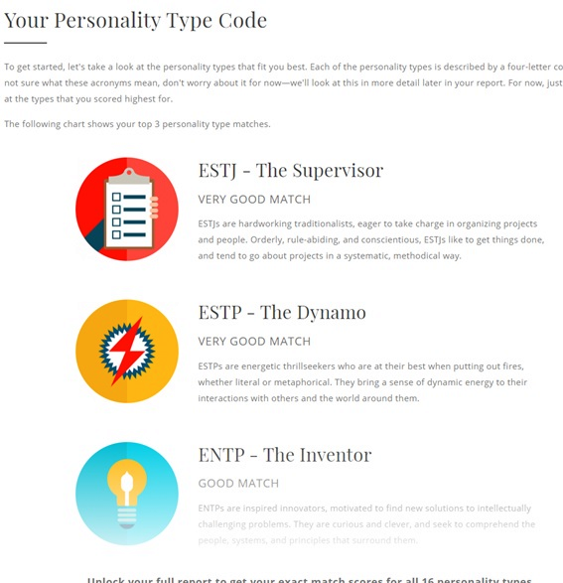

#### Personality test

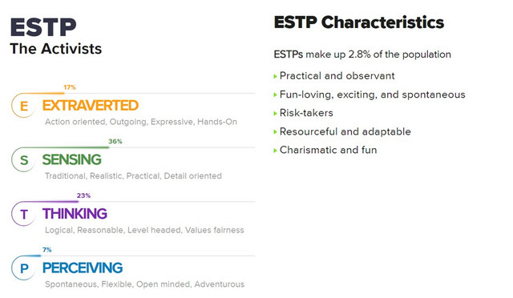

#### Numeracy Test

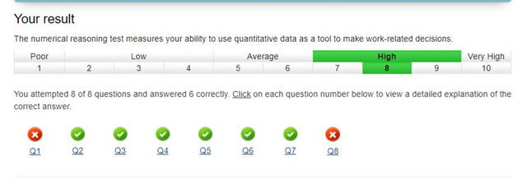

### Ryan Williams

#### Meyer-Briggs Test

<https://www.16personalities.com/profiles/2b0ec0d4ce2f1>

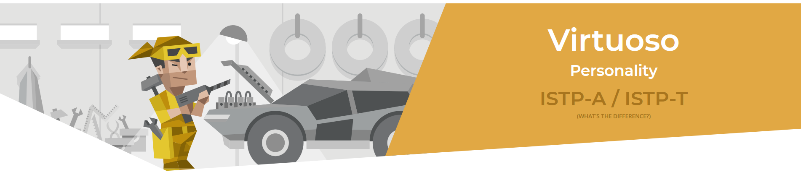

#### Learning style Test

<https://ryan-williams1.github.io/IIT/Learning_Style_Results.pdf>

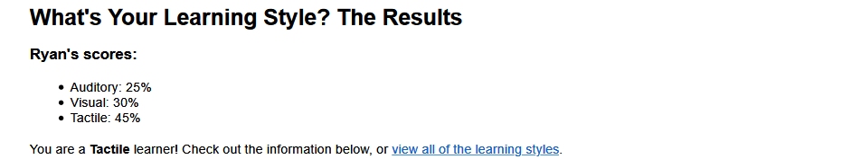

#### Psychometric Test

<https://www.carecareers.com.au/quiz/result/id/1354786/token/6f539e2e#.XpmP6JnhWUl>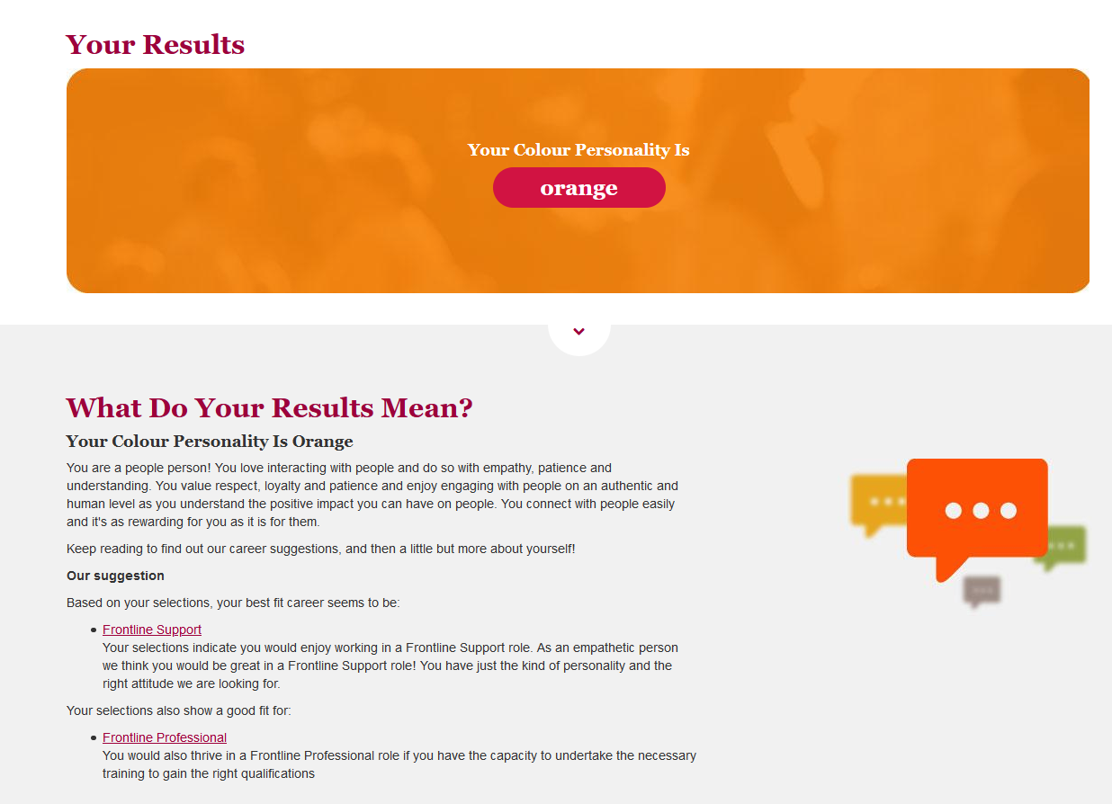

### Benjamin King

#### Myer-Briggs Test

<https://www.16personalities.com/infj-personality>

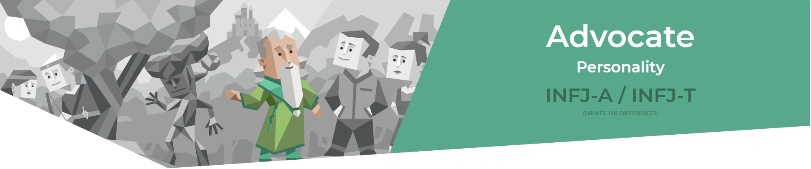

#### Learning Style test

<http://www.educationplanner.org/students/self-assessments/learning-styles-quiz.shtml?event=results&A=7&V=6&T=7>

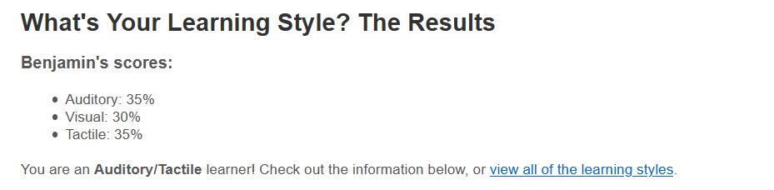Big 5 Personality Test

<https://www.truity.com/test/big-five-personality-test>

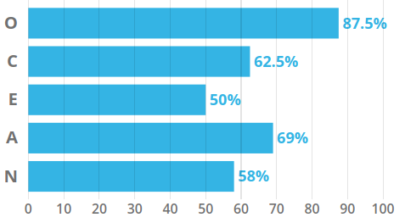

### Douglas Baker

#### Myer-Briggs Test

<https://www.16personalities.com/istj-personality>

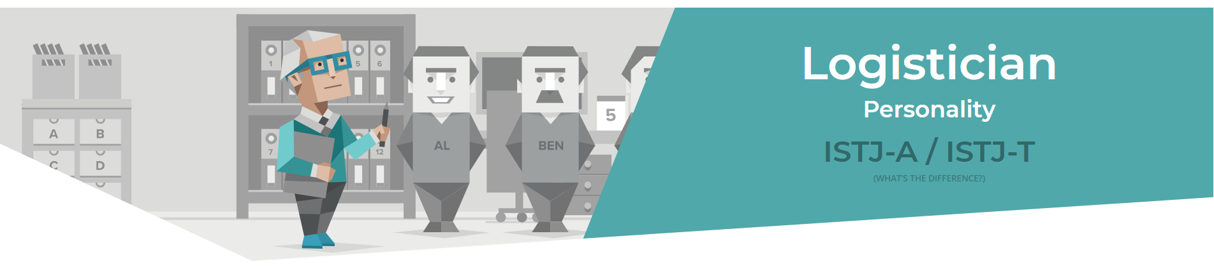

#### Myer-Briggs/Jung test

<http://www.humanmetrics.com/>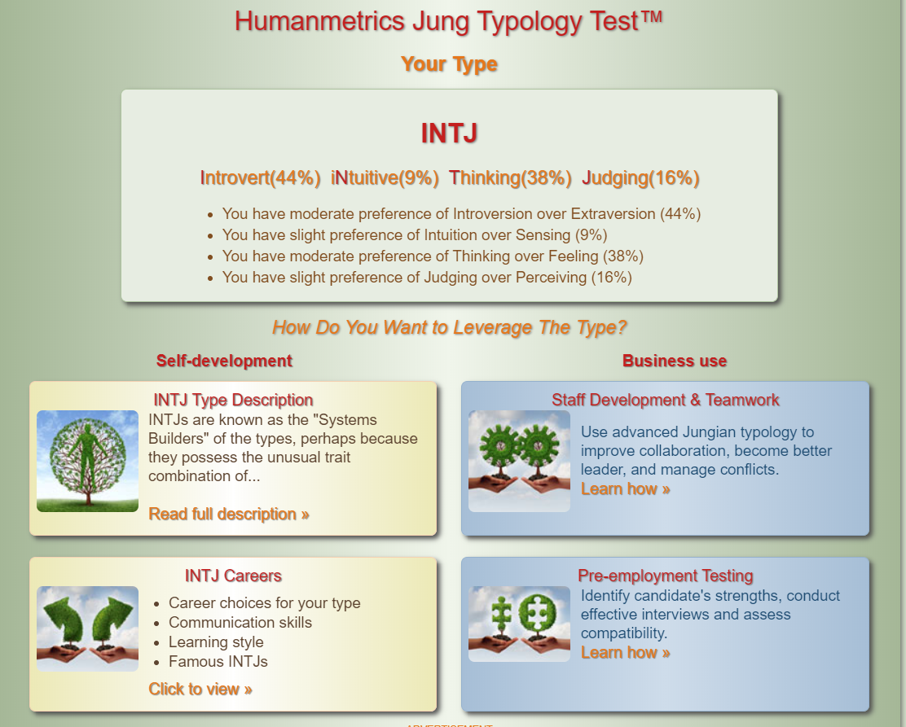

#### Big 5 Personality Test

<https://www.truity.com/test/big-five-personality-test>

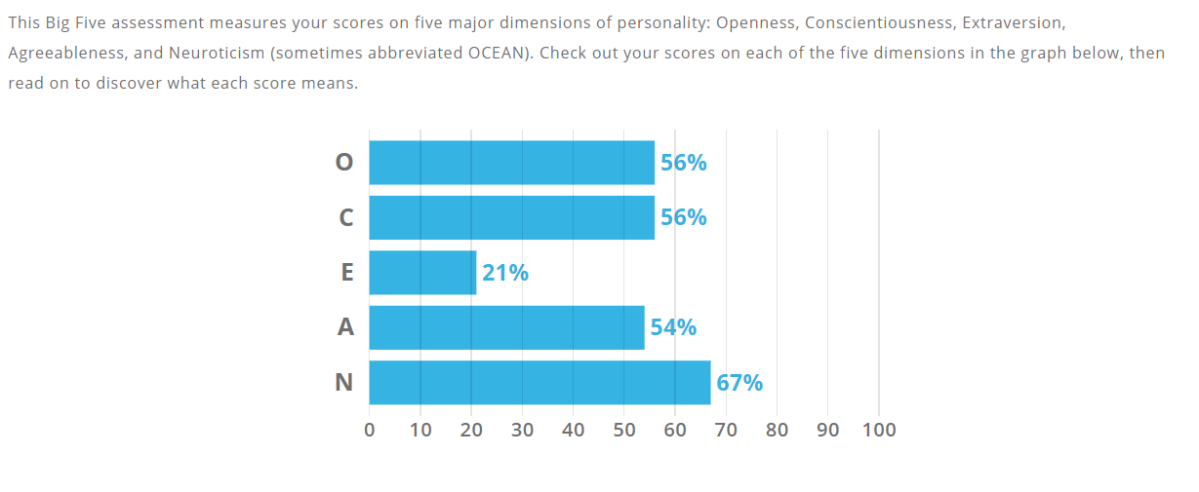

### Ty Lynch

#### Myer-Briggs Test

<https://www.16personalities.com/istj-personality>



#### Learning Style Test

<http://www.educationplanner.org/students/self-assessments/learning-styles-quiz.shtml?event=results&A=6&V=9&T=5>

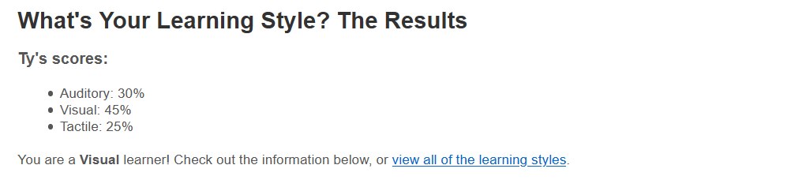

#### Big 5 Personality Test

<https://www.scienceofpeople.com/personality-quiz-results/?score=386050647.14>

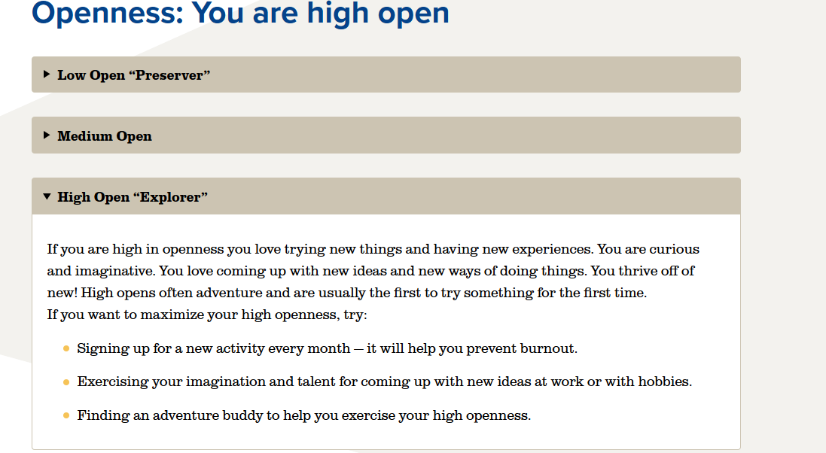

### Morgan Cassar

#### Myer-Briggs Test

<https://www.16personalities.com/istp-personality>



Learning Style Test<http://www.educationplanner.org/students/self-assessments/learning-styles-quiz.shtml?>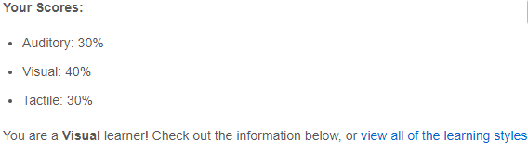

#### 

#### The Big Five Personality Test <https://www.truity.com/test/big-five-personality-test>

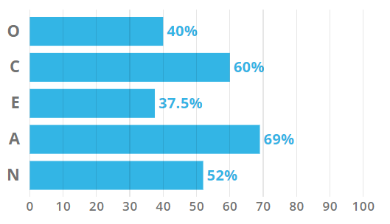

## Comments

### Robert Cross:

Across the entire group there is a diverse range of personality types as presented in the above results. I feel that in a larger group having a blend of personality and behaviour traits results in better communication overall and a more cohesive group. People will always prefer to work and divide tasks in a way that they feel comfortable doing and will potentially gravitate to different pieces of work depending on their personality trait e.g. web design over documenting a report. I think that given the range of personalities our team has worked well in dividing up the relevant tasks as well as communicating at a high level throughout the project. This may not have been possible if the entire team shared the same personality traits.

### Ryan Williams:

Having the same personalities test result can go either way, I feel having a mix of strong personality types has helped the team, being able to respect and understand opinions has been the foundation of this team, without everyone’s input the team would not have achieved what we did. Regardless of test results or personality tests, if the team is respectful and focused, they can meet all of the goals set out. Our team has worked as a well-oiled machine (in between other life commitments) with not apparent issues.

### Benjamin King:

Any team is capable of working with differing types of personalities provided respect is shown by all members. Our team has shown that a range of personality types can work together well to achieve a common goal. I believe that our driving force was not so much our differing personality types, rather it is our interest and passion for all things IT related. It became very apparent quickly that we were all on the same page and that we had a good team on our hands.

### Douglas Baker:

From my experience any differing personalities in a team can work together as long as all the members make a decent attempt to work with each other. I have also found for myself if I can work with someone with some similar traits to myself it is often handy to highlight things that I may have overlooked.

### Ty Lynch:

I think that it is interesting that Douglas and I share the same results in the 16 personalities test which means we could either but head or work together quite well. Morgan and Ryan seem like they will make good team members willing to get in there and lend a hand where they can while also allowing others to have their freedom and collaborate on their tasks also. Benjamin’s 16 personality test mentions him being soft-spoken but from what I have seen so far, he is quite the leader organising the group in a fair and orderly manner. While it also seems Robert will make a good leader from his Myer-Briggs style test and his selection of job role.

Morgan Cassar:The fact that me and Ryan share the same result on our 16 personalities test means that I think we would work well together due to our personality type, being someone who is willing to work together on things towards a goal. Douglas and Ty, also share the same personality result, they are responsible people, and from what I can gauge from what they have done for this assignment, they have been very responsible, calm and practical and worked well with everyone in the group. Robert seems to have the personality who is dedicated, which he has shown through this assignment. Bens personality describes him as insightful and decisive, which he has definitely shown throughout this assignment.

# Tools

We as a team used Microsoft Teams and GitHub to collaborate this project, Microsoft Teams was a valuable tool that enabled the team to communicate effectively. GitHub is was amazing and allowed a central file version which was updated by each member as needed, we also had a channel in Microsoft Team that was used for GitHub push and pull notifications to reduce possible push conflicts. The team assessment was broken into parts and our team opted for the divide and conquer approach, this allowed each member to have a small part then upload and communicate their findings.

The audit trail on GitHub reflects the teams work to a degree, it only shows when data was pushed to GitHub and does not reflect the work that each person put in, an example of this would be the interview, Douglas put in a lot of preparation time and gathered the questions from the team using Microsoft Teams but on GitHub it only shows a very small snapshot of that work in the audit trail. As a team we feel that relying on the audit trail is not a good measure of the work that everyone has put into the assessment.

## Links to the team resources:

Team Website - <https://imagine-dragoons.github.io/RMITA3G15/>

Team GitHub - <https://github.com/Imagine-Dragoons/RMITA3G15>

# Project Description

## Overview

Our project for assignment 3 will be the development of an application to be used in the Childcare industry of Australia to monitor and track the required observations of learning outcomes for children in a day care setting.

In the Child Care industry each child’s learning outcomes are assessed on a monthly basis which is primarily a manual task. Our project deliverable is to design and develop a Java application that will be to be used across multiple platforms that aims to reduce the amount of time spent on paperwork and thus allowing educators to focus their time on children, improving their education experience.

.

This project will involve work in several IT areas including:

* Developing the application using a Java IDE
* Server-side knowledge for hosting and potential data storage
* Using a GitHub repository to store and access the project files
* Applying a testing and QA methodology to identify any issues and provide a feedback on changes
* Providing an easy to use and effective UI experience
* Implementing secure data security, storage, and encryption for private information

## Motivation

Currently in Australia there are more than 15,000 childcare and education services that operate under the national quality framework. Workers across these services must record the observations of multiple learning outcomes for each child in their care, today this is a manual process which involves tracking these observations manually.

Improving the working capacity of employees in an essential industry by providing an alternative that is easy to learn and use for all users, regardless of background of IT knowledge is a key motivation for our team and this project.

Providing an easy to use mobile application – or application that can be used across multiple devices – to replace potentially redundant manual work is something that is all too familiar in today’s IT landscape. Improving business processes and ways of working is a key aspect of Information Technology and targeting an industry as critical as childcare in Australia will provide a lot of exposure and potentially a lot of users.

Technically using a programming language such as Java and utilising a cloud storage option providing essentially 24/7 availability is becoming the norm with most applications in the IT industry.

Completing this project would demonstrate to a future employer a number of positive aspects:

* Competency in a commonly used development language (Java)
* Knowledge in maintaining storage of data – and potentially exposure to encryption and various aspects of data security
* Working effectively in a team – assigning tasks, high-level communication and escalation management
* Showing initiative in learning new skills and exploring what options are available for designing and completing a project

## Landscape

Based on our group’s research we believe there is little to no competitors that we would be up against the in this space and industry. This could be due to several reasons:

* Barriers to change that exist within the industry such as users not willing to adopt new processes or change. A lot of industries use legacy processes and ways of working because they are familiar and have worked in the past. This can make it difficult to implement change or introduce new systems.
* A heavily regulated industry such as the childcare industry could be intimidating and prove too difficult to approach with a new solution or application. However, we have shown so far that with the correct planning and ensuring that any application and software that has the flexibility to adapt to these changes can be successful.

Although we have not been able to uncover any information on competing applications that are also targeting this space it would be naïve to assume, we are the only application vying for change in the market. This must be reflected in our overall project plan and it must be robust and flexible enough to be able to go head-to-head against potential competitors.

## Detailed Description

### Aims

The aim of our application is to make redundant the manual work that is currently done to record observations of learning outcomes in day care centres. These outcomes must be recorded per child throughout the course of a year at these centres, some 15,000+ across Australia, which results in loss of time spend educating children. Recording and maintaining almost any sort of vital information in any industry should be looked at as potentially an issue – user error, damage and even storage of paper-based sensitive information can be hazardous and poses an unnecessary risk when compared to the alternatives an IT solution such as our application could offer.

Our aim is to be the primary used application across day care centres in Australia for recording these observations, essentially being a market-leader due to the current lack of competitors in the field and because of the innovation and updating of current business processes we will target.

The first goal must be to provide a practical and intuitive UI as our target market is potentially end-users with limited or no IT knowledge and background. The application must be easy to use and incorporate into every-day practice – users must clearly see the benefits of adopting a new solution or tool to ensure a high level of user adoption. Disrupting an industry-wide practice regardless of the potential positive impact is very challenging and without an easy to use application we risk not making it past an early hurdle.

Ongoing development and future scalability of features means that the application must be developed in a well-know, robust programming language. Because of this the design up until this point has been done in Java. This should somewhat ‘future-proof’ the application in regard to maintaining code as well as potentially expanding the scope of the application and even having other developers review and contribute to the code. Java is a very common programming language that is widely used in the development of applications – so we are reducing the risk of developing in a language that may become outdated or sub seeded by another programming language (or tool) in popularity.

Due to the industry that the application is targeting another goal will be to ensure that all government regulations and requirements relating to the childcare industry and the use of technology are met. Regulations and processes around storing of sensitive and personal data (names, addresses, age etc) along with how this information is encrypted and accessed are key areas that will require on-going attention. Our goal is to ensure that the application is flexible enough from a development standpoint that the ever-evolving regulations and rules can be met and any changes aren’t detrimental to the application – or would result in long-term downtime of the application.

### Plans and Progress

#### How application began – history and background

The application began approximately 24 weeks ago as an idea for an assessment in a previous study period, and the primary focus was to develop and application that would be used in the childcare industry to reduce the reliance on paperwork and replace the current manual processes with an application. Ryan started working on the application during this time in order to reduce paperwork for his wife who works in the childcare industry.

Essentially the first phase of development has included our wider team since the Imagine Dragoons were formed earlier this semester, ramping up for assignment 3 based on the requirements and deliverables needed for this assignment – as well as future group work that is still to be submitted prior to the semester’s end.

#### What has progressed since Assignment 2?

There has been significant development work that has been completed since Assignment 2 on the application which has subsequently resulted in testing, QA and feedback following these changes.

Development changes to the project file were required to create a new runnable project file as well as changes to the UI – including an updated menu.

#### Tools used for development and development process?

The primary tool that has been used is Java SE Development Kit (JDK) which is a software development environment used for development of Java applications. Our team has also continued to use a Git Hub repository, so all members have access to the project files, and the ability to make changes, complete testing, and quality assurance throughout this project phase.

Although not a development tool, Microsoft Teams has been extensively utilised throughout the project. Teams has allowed the entire group to stay in regular communication, used to assign deployment tasks and provide feedback and updates to other team members. Project management is a key and potentially underestimated aspect of a development project, keeping on top of tasks and admin work is vital to ensure that deadlines can be met.

#### Development problems that have been encountered

Due the fact the application has been developed using Java ensuring backwards compatibility with older Java versions has been something that we need to consider. For example a project compiled on the latest version of Java won’t run on an older version of Java – which shouldn’t be an issue for people with a background or knowledge in IT, however in the wider context of the project would mean that all devices utilising the application would have a minimum version requirement. This is challenging as is it can be somewhat out of the hands of our team once an end-user(s) starts using the application. Ensuring users update their devices is not an uncommon problem for applications, however this could potentially be a serious challenge.

Another key issue which has impacted the development of the application has been keeping in line with the national framework used by the childcare industry in Australia – these requirements and regulations are constantly evolving and means that any changes to the application (data storage, form information, observation notes, etc) might need to be made at short-notice. Most applications and projects have a roadmap based on ideas and innovations they wish to see in the future; however, we would need to ensure that some future capacity is designated to the possibility of this framework changing.

#### Any changes from the original idea?

The original idea was to develop an application that could provide a way to tack the learning outcomes for a particular observation for a child digitally that would reduce the need for paper work and records whilst also reducing the overall time spent by an educator documenting these observations.

We feel that the original idea still exists, the application however has needed to evolve to match the current needs and environment of the childcare industry. There have been no major changes to the original idea that been made due to the changing needs and requirements.

#### Testing and QA process in Assignment 3

Given that the project had to be completed in a fairly short amount of time along with the fact that there were a number of development changes and subsequent testing, we required a proven testing & QA methodology to follow to ensure that a robust and well tested application was the end result. Several popular methodologies were considered (Agile, Waterfall, Extreme programming) however we decided that the iterative method would be the most effective for a project of this size and number of team members.

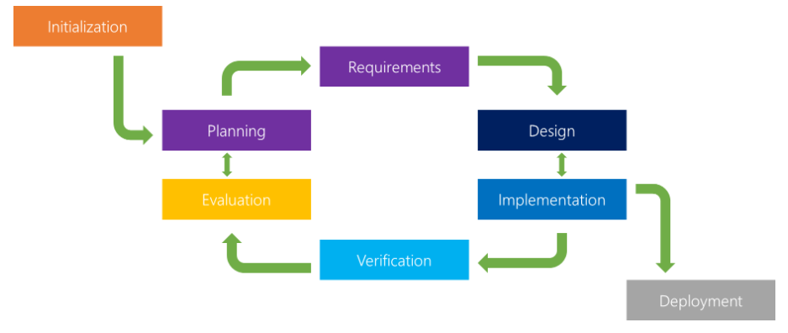

Figure 1 Example Iterative QA Methodology Workflow

Following assignment 2 we had an initial version of the Childcare Observations application – this meant that for the planning & requirements we could simply build on the original version and add a subset of requirements and goals that would be targeted for assignment 2.

During the assignment there were a number of iterative changes made to the application (Code changes, UI changes, changes to executable file) which resulting in a various ‘cycles’ of the QA process to ensure that all changes were tested, verified and evaluated by the team before any further changes were planned and developed.

The strength of this QA process is that it allows for smaller, ongoing changes to the application to be completed and tested prior to the final deployment. This means that any issues or bugs with the changes or usability of the application are identified quickly and are less likely to impact a final deployment or deadline.

#### Future plans and opportunities to improve application

Several improvements to the application that could be targeted in the future have been identified and incorporated into our extended timeline (+10 weeks). These include both new features and functionality as well as making improvements to some existing functionality that has been developed up until this point.

A key development change will be a design change to allow the application to run in 1 window – currently pop-up windows are required when navigating the application and selecting different menu options. This change would increase the usability and overall UI experience for the end-user.

From an infrastructure & hosting perspective changes will be made to allow the secure saving of a file type other than .csv – which is currently the file type that is saved. Ideally some form of encryption at rest and a secure transfer method would be required given the data that will be saved. Personal information as well as details on the child’s observations are potential risks and is data that would need to be securely stored.

Prior to end-user testing changes have also been planned to accommodate an improved menu as well as help files. During end-user testing any FAQ’s that users may need to review – or the ability to log feedback and issues found – means that some further development changes must be made to the application to allow this.

### Roles

Our group decided that the roles required for this assignment were not necessarily permanent and due to the work required would need to be fluid and require everyone to work on different elements throughout the course of the project. However, in saying this, there were group members who had much more relevant skillsets and experience that also governed how different tasks were divided up during the assignment.

Generally, the 3 roles that were identified and determined how and where work was assigned are outlined below:

**Developer**This involved the Java design coding of the application based on the overall project plan and requirements that were outlined for the application. We also utilised GitHub to store the project files and manage any coding changes that occurred throughout the project.

**Testing & Quality Assurance**

A key role of any project and also critical to our assignment was the role of completing testing and QA of any changes that were made to the application. Using an iterative approach when testing meant that smaller code changes could be made targeting specific areas of the application before undergoing a round of testing and feedback from a team member who be assuming the role of a tester.

**Project Management**

Another role that was also shared between the team at various stages was that of a project manager, there were a number of parts and moving pieces of the project that had to be maintained and assigned throughout the project which meant that on-going project management was critical to the success of the project. Using Microsoft teams for communication and GitHub for storing and maintaining documentation meant that these roles responsibilities could be shared between the team members at various stages of the assignment.

### Scope and Limits

Our scope has been based on the deliverable artifacts within the scope of the assignment timeline and an extra timeline of ten weeks.

Within the timeframe of the assignment we were able to deliver a new user interface, a code base cleanup to improve the readability of the code and perform local testing across Imagine Dragoons computers to establish the need to update the JRE/JDK working environment to include support for JDK 14.

With further development time, we would be able to implement local storage encryption as is required for sensitive data relating to children. We would also be able to increase compatibility with further testing and add a help section.

Ideally with extra time to work on the project, we would add mobile compatibility for android and iPhone with dedicated servers to host both the applications development as an SaaS with an encrypted data storage solution that meets the legal requirements of sensitive information storage.

|  |  |  |
| --- | --- | --- |
| Scope | | |
| In Scope | | Out of Scope |
| A3 Timeline | A3 + 10 Weeks |
| User interface update | Development & integration of help files | Mobile application development for android and iPhone |
| Code base clean up | Updated menu | Dedicated SaaS server |
| Upgrade executable to support newer version of JDK 14 | Local secure data storage using local encryption | Server side encrypted data storage |
| Local testing & evaluation | Refresh of user interface for use by industry. |  |
|  | Local testing & evaluation |  |

### Tools and Technologies

A number of tools and technologies have been used for the development process and for the eventual deployment of our project. They have been broken down into their various components and uses in the following tables.

|  |  |
| --- | --- |
| Windows or Linux Development Environments | |
| *Software* | *Development License Required* |
| Eclipse IDE | <https://www.eclipse.org/legal/epl-v10.html> |
| Java JDK 13 & 14 | <https://www.oracle.com/downloads/licenses/javase-license1.html> |
| Microsoft Teams | <https://www.microsoft.com/en-au/servicesagreement> |
| Adobe Acrobat Pro | <https://acrobat.adobe.com/au/en/acrobat/pricing.html> |
| Brackets | <https://creativecommons.org/licenses/by-sa/2.5/> |
| Notepad++ | <https://www.gnu.org/licenses/gpl-3.0.html> |
| Git | <https://opensource.org/licenses/GPL-2.0> |
| Chrome | <https://www.google.com/chrome/terms/> |
| Firefox | <https://www.mozilla.org/en-US/MPL/> |

|  |  |
| --- | --- |
| Deployment Environment Requirements | |
| *Software* | *Commercial use License* |
| MS Win10 | [https://microsoft.com/en-us/licensing/product-licensing/windows10](https://www.microsoft.com/en-us/licensing/product-licensing/windows10) |
| Java SE 8 | <https://www.oracle.com/java/java-se-subscription.html> |

|  |  |
| --- | --- |
| Programming Languages, Markup Languages & File Formats. | |
| *Format/Language* | *Information* |
| Java | <https://www.java.com/en/> |
| C++ | <https://www.w3schools.com/cpp/cpp_intro.asp> |
| CSV | <https://tools.ietf.org/html/rfc4180> |
| HTML | <https://www.w3schools.com/html/html_intro.asp> |
| XML | <https://www.w3schools.com/xml/xml_whatis.asp> |
| PDF | <https://acrobat.adobe.com/au/en/acrobat/about-adobe-pdf.html> |

|  |  |
| --- | --- |
| Hardware Required for Development and Deployment | |
| *Development* | *Deployment* |
| Desktop Computer/s & peripherals capable of running Microsoft Windows 10 | Desktop Computer/s & peripherals capable of running Microsoft Windows 10 |
| Router or modem for internet connection |  |

|  |  |  |  |  |  |  |
| --- | --- | --- | --- | --- | --- | --- |
| Imagine Dragoons Technology Experience Level Matrix | | | | | | |
|  | *Individual Member’s* | | | | | |
| *Technology* | Ryan | Ben | Morgan | Douglas | Ty | Robert |
| Java | 3 | 1 | 1 | 1 | 1 | 1 |
| C++ | 1 | 1 | 1 | 1 | 0 | 0 |
| HTML | 6 | 3 | 3 | 1 | 2 | 0 |
| Eclipse | 3 | 1 | 1 | 1 | 0 | 0 |
| Acrobat Pro | 6 | 0 | 0 | 1 | 0 | 0 |
| Git | 3 | 2 | 2 | 1 | 2 | 0 |
| Office Apps | 10 | 4 | 4 | 10 | 3 | 10 |

*Table Legend:* Cells coloured Red indicate a non-professional level of experience as a self-assessed rating of 0 (nil experience) to 5 (high experience). Cells coloured Yellow indicate professional level of experience in numbered years.

### Testing

Throughout the assignment we have been following an iterative testing methodology that has given our team the flexibility to continue development of different areas of the application before testing and receiving feedback verification of changes from the team members. Ideally, we would continue to use the iterative testing methodology for future planning, development and subsequent QA and testing of the application.

Although the iterative methodology has been successful for the initial development phase eventually, we will require end-user testing the application, which we will need to take a different approach to testing and receiving feedback.

After reviewing different methodologies for end-user testing, we have decided to the most suitable for our application would be unmoderated remote usability testing. Given that the industry our application will be utilised in wouldn’t be suitable for on-site or guerrilla testing we need an approach without a moderator present, whilst still provide enough users to produce a large enough sample size for feedback and reporting of any issues.

Unmoderated remote usability testing occurs remotely without a moderator, it is quick and inexpensive whilst still providing testing results and feedback. We would ask end-users to trial the application in their day-to-day roles and provide a platform for them to provide feedback or report any issues – most likely via a quick survey, or by providing a contact email.

We would potentially have access initially to a sample size of test end users given Ryan’s history and contacts within the childcare industry. This would be a good way initially to gauge how successful testing is and what type of feedback and issues are encountered initially before extending the scope of test users.

One drawback would be that without a moderator present we would receive less detailed information, or users would have to wait to receive feedback for any questions they had or any issues that were encountered with the software. However, weighing up the available options we feel that this is the less intrusive way to have a large number of potential end-users to test the application and provide the feedback that would be required.

### Timeframe

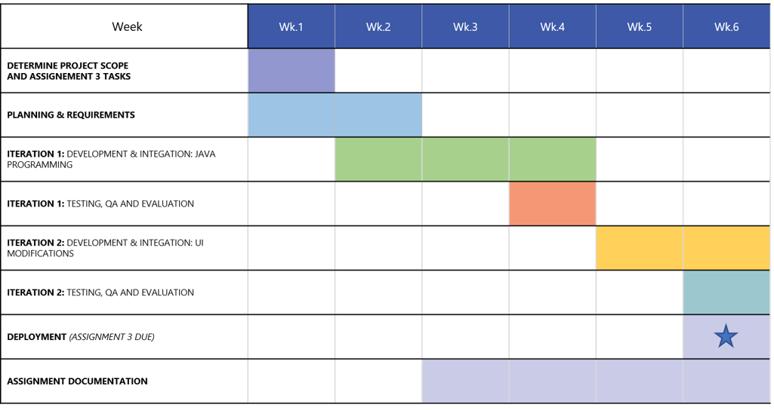

**Future Plan to Improve Application:**

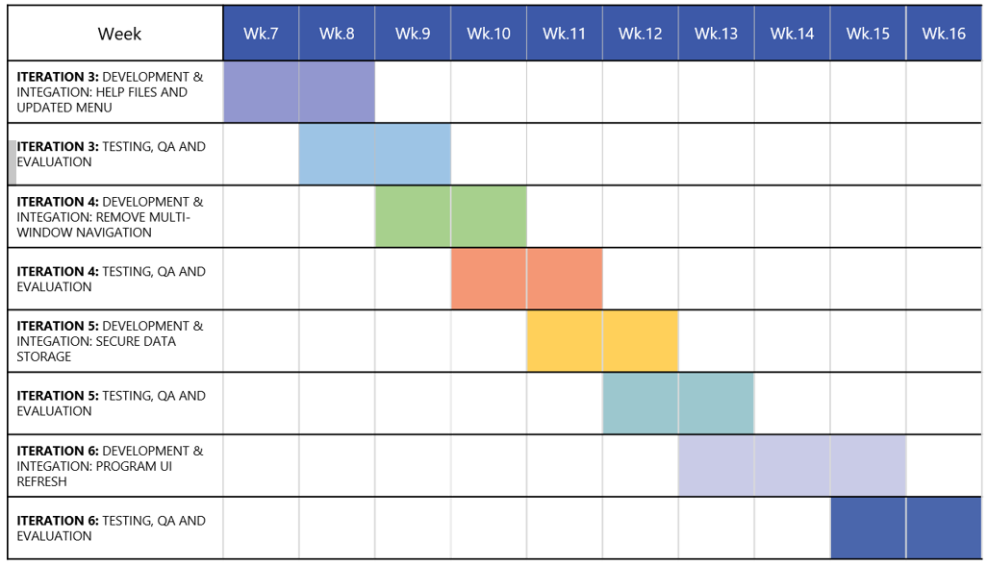

### Risks

As with any IT project and application there are going to be risks that might impact the project either partially or proceed to be a critical or ‘showstopper’ risk that cannot be mitigated. We have outlined numerous times in this document the childcare industry must operate a strict and evolving set of government and industry regulations, and although we have ensured that the application and development has taken this into consideration thus far – and also makes plans in our future timeline – there is a risk that changes to policies around data storage, childcare policies or even applications that may be approved for usage are all potential risks that might be encountered deeper into the lifecycle of this application.

Another key risk that might be potentially overlooked is successful user adoption of a new tool that will become a part of the everyday business process for some people. This is often a major challenge and involves ensuring that future end-users of the application feel that there is enough benefit to making a change to a new tool and have the confidence in that it will improve their current processes whilst being easy to use and learn. Any lack in confidence or issues with the application heightens the risk of users simply moving back to their old ways of working – which although we know can be improved, have been proven to work in the past.

### Screen shots of the app improvements

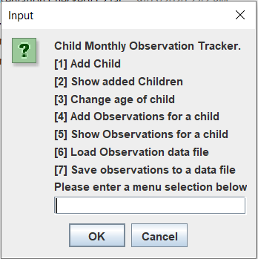

As seen in the picture above (app version 1.1) the main menu requires text input from the user which would then load the relevant method of the app. This is not user friendly but is enough from proof of concept.

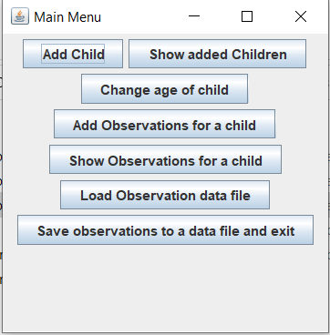

Above (app version 1.2) the main menu has been improved into buttons, these buttons will receive further improvements to alignment, size, shape and colour in later versions.

### Group processes and communications

During the early stages of this semester when our group was first formed, we have been utilising Microsoft Teams as the primary communication tool for our group. This has been extremely helpful in almost all aspects of managing this assignment and ensuring that all members have a direct line of communication for feedback, updates and general communication and discussion throughout the semester.

Primarily flagged as a communication tool we have also been able to use Teams for other aspects of our assignment such as,

**Project Management**

* + Creating channels for the breakdown of the assignment and requirements for each section
  + Assigning and volunteering for tasks for the assignment
  + Sign-off of completed sections and work once available for review

Fortunately, we have not had to implement any escalation procedures during this assignment – or in the previous assignment this same team completed earlier this semester. Ideally if there were non-responders or missing/not completed work we could discuss internally in the team and as a last resort potentially escalate to a tutor for the course.

Thankfully, we have been able to focus solely on the assignment work and details and not be distracted or feel like the quality of work has diminished because of having to deal with negative aspects of team communication.

# Skills and Jobs

The following skills and jobs we have identified as appropriate to add to our team are:

* Database Administrator
* Project Manager
* Senior test engineer
* Developer

We believe that the roles listed are essential in creating our application. As our application will require a backend server to handle sensitive user data we believe that a Database Administrator would be required keeping this information private is a massive issue so someone with experience is a necessity in keeping a secure server is a must.

A Project Manager would be required to drive the project to be completed in the 6-month timeframe. They would be able to deliver information to the investors in a way they understand so they are comfortable in knowing they have made a sound investment.

We believe that it would benefit this project by delivering the best end product we possibly can while this role is not necessarily essential at the beginning of the project this role. It would become useful at the near the middle to end of the project.

We have identified that we would need a Developer to improve upon what we have already created. We have begun the first stages of this application with some previous knowledge in Java. Due to this, we would like to avoid changing the programming language so someone with experience in Java would be a must. It may also be necessary that the Database Administrator might find it difficult to complete the task in the timeframe. So, it may be helpful if they had experience in that field as well.

## Database Administrator

### About us:

We are an up and coming start-up who has recently secured funding to support the development of an application servicing the childcare industry. The application being developed will allow educators to track observations of learning outcomes for Individual children. This is currently a long manual task; we wish to make this process less time consuming by automating this task as much as possible.

### About this role:

We are currently searching for an experienced Database Administrator with a background working with PostgreSQL to join the Imagine Dragoons team. We are at the beginning stages of this project and we are looking for a passionate individual to see this project through with us.

This is an amazing opportunity to start a project from the early stages to completion and gain further experience in your role as well as the opportunity to implement your ideas.

### To apply you will need:

* Experience in a similar relevant position
* Sound knowledge of database security concepts
* Previous experience with Oracle Database administration
* Willing to work in a team environment
* Great oral and written communication skills
* Experience with Agile development methods

### How to apply:

Please submit your CV and resume to

[admin@imaginedragoons.com.au](mailto:admin@imaginedragoons.com.au)

## Project Manager

### About us:

We are an up and coming start-up who has recently secured funding to support the development of an application servicing the childcare industry. The application being developed will allow educators to track observations of learning outcomes for Individual children. This is currently a long manual task; we wish to make this process less time consuming by automating this task as much as possible.

### About this role:

We are currently searching for an experienced Project Manager with a background working in a similar role to join the Imagine Dragoons team. We are at the beginning stages of this project and we are looking for a passionate individual to see this project through with us.

This is an amazing opportunity to start a project from the early stages to completion and gain further experience in your role as well as the opportunity to implement your ideas.

### To apply you will need:

* Experience in a similar relevant position
* Bachelor of Information Technology or equivalent qualification
* Certifications in Project/Program management a plus
* Developing performance reporting which is meaningful to the relevant parties.
* Willing to work in a team environment
* Strong Problem-solving skills to be able to resolve issues quickly and efficiently
* Great oral and written communication skills
* Experience with Agile development methods

### How to apply:

Please submit your CV and resume to

[admin@imaginedragoons.com.au](mailto:admin@imaginedragoons.com.au)

## Senior Test Engineer

### About us:

We are an up and coming start-up who has recently secured funding to support the development of an application servicing the childcare industry. The application being developed will allow educators to track observations of learning outcomes for Individual children. This is currently a long manual task; we wish to make this process less time consuming by automating this task as much as possible.

### About this role:

We are currently searching for an experienced Test Engineer with a background working in a similar role to join the Imagine Dragoons team. We are at the beginning stages of this project and we are looking for a passionate individual to see this project through with us.

This is an amazing opportunity to start a project from the early stages to completion and gain further experience in your role as well as the opportunity to implement your ideas.

### To apply you will need:

* Lead and develop testing strategies
* Experience with Java a must
* Complete Applicable levels testing required to produce quality software
* Report and manage risks and defects in accordance with Agile development methods
* Willing to work in a team environment
* Great oral and written communication skills

### How to apply:

Please submit your CV and resume to

[admin@imaginedragoons.com.au](mailto:admin@imaginedragoons.com.au)

## Developer

### About us:

We are an up and coming start-up who has recently secured funding to support the development of an application servicing the childcare industry. The application being developed will allow educators to track observations of learning outcomes for Individual children. This is currently a long manual task; we wish to make this process less time consuming by automating this task as much as possible.

### About this role:

We are currently searching for an experienced Developer with a background working in a similar role to join the Imagine Dragoons team. We are at the beginning stages of this project and we are looking for a passionate individual to see this project through with us.

This is an amazing opportunity to start a project from the early stages to completion and gain further experience in your role as well as the opportunity to implement your ideas.

### To apply you will need:

* 4 Years of experience in Java development
* PostgreSQL experience Regarded highly.
* Experience with Agile development methods
* Willing to work in a team environment
* Great oral and written communication skills

### How to apply:

Please submit your CV and resume to

[admin@imaginedragoons.com.au](mailto:admin@imaginedragoons.com.au)

# Group Reflections

## Posts excerpts from Microsoft Teams

[14:18] Benjamin King

I guess one thing I found surprising was just how deep Java seems to be. There is a lot more going on there than a quick look at the code. It will take me some time to wrap my head around it

[19:33] Morgan Cassar

I guess, it was interesting seeing how the program all worked and it gave me some insight in java programming.

[19:36] Benjamin King

Yeah I found Java interesting and challenging. It has been some time since I jumped into programming and I was pretty glad Ryan Williams had the experience as I discovered I couldn't help with the code at all. I've a long way to go

[19:37] Douglas Baker

I think that this assignment has presented different challenges in trying to make sure we can all contribute. With an applications at the early stages of development, the requirement gathering and initial proof of concepts through to MVP stages are a challenging thing to do especially in a fully remote team. An aspect of the Teams platform we have not made use of is the video conferencing features to get together in a virtual meeting room. Traditionally in a team people would lock themselves into several small meeting and have formal documented requirements gathering with prospective users. The full requirements gathering is not really practical in the scope of the assignment, and the virtual meeting room may not have worked with differing work schedules and commitments. That being said if we were a group looking at this being a startup with some financial goals things would be different.

[19:47] Ty Lynch-Palmer

I agree with Douglas it been difficult to find ways to all be able to contribute. I think communication was better with this assignment time but i think we should have organised set meeting times through out the project to communicate as a team.

[19:51] Benjamin King

I agree also. Maybe a quick meeting time to just voice what we are thinking about doing in the assignment would have been a lot more efficient than multiple posts. Ill straight up say that in this assignment, my attempt at trying to break it down in Teams as channels seemed to cause more confusion than help.

[20:04] Ryan Williams

Yeah I fully agree with all of this. The break down is helpful but can also cause confusion regardless if the goal was in the best intentions of the project.

[20:11] Robert Cross

Managing the assignment and progress of tasks was one of the more challenging aspects, however I think we did a pretty good job considering the scope of the assignment and what was needed as a deliverable. It's been very interesting to be involved in a project that I'm interested in, however as others have mentioned we probably could have been a little better with communication and scheduling time to catch-up. Although overall really happy with everyone's input and think we have done a great job.